August 2015 Narrative report
Planned Activities for the month
- One on one engagement meeting to 3 Legislators
- Advocacy meeting with Hon Commissioner for Gender Affairs and Social Development
- Two day workshop for preparing drama scripts and synopsis.
- 1st Inaugural meeting of NCAA PIC Members
- August meeting sensitization on GEOB
ONE on One Engagement meeting with 18 legislators
Advocacy meeting with the Majority Leader of the House (Hon Ikechukwu Mellitus Ezeugwu)-August 10th 2015
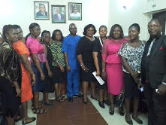
Advocacy meeting with the Speaker of the House, Hon. Edward Uchenna Ubosi
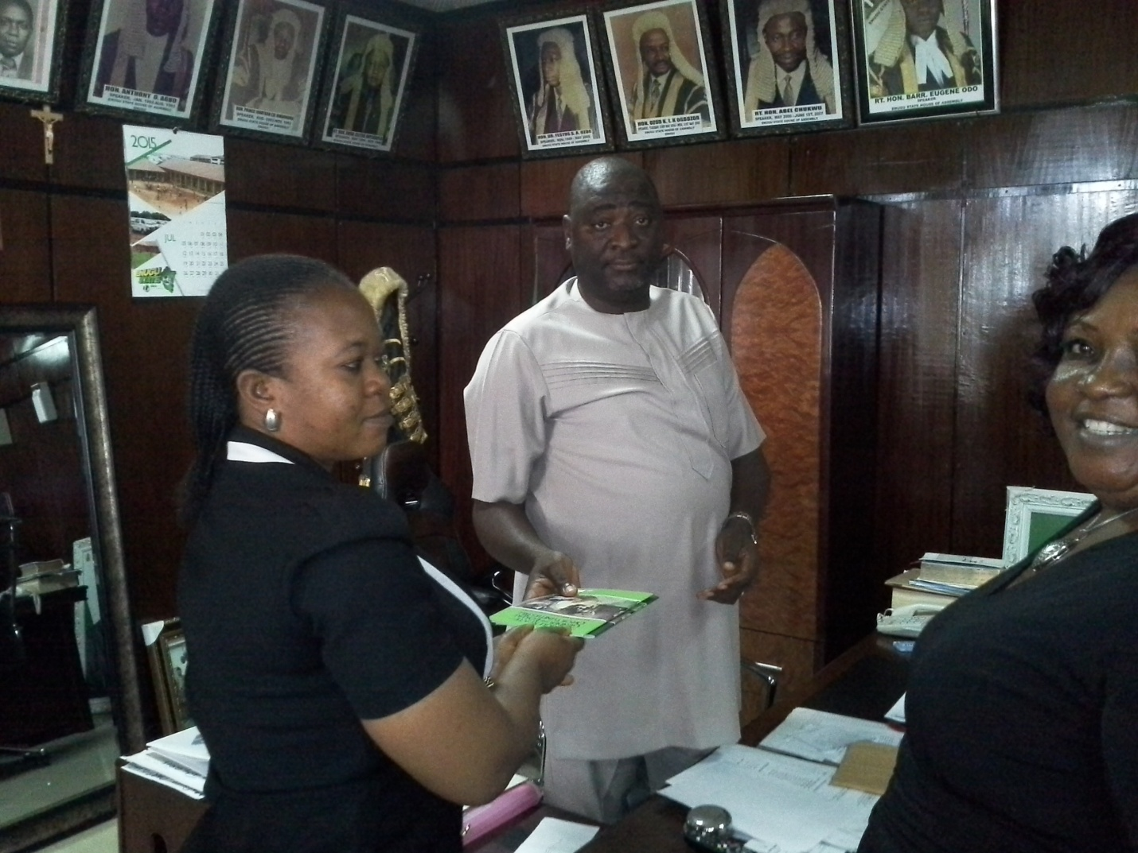
Picture showing Ogechukwu Enwelum (NCAA Member) presenting GEOB to the ENSHoA Speaker in his office
Advocacy meeting with the deputy leader- Hon Mary Onyinye Ugwu – 20th August 2015
Advocacy visit /meeting to Hon. Commissioner for Gender Affairs and Social Development Enugu

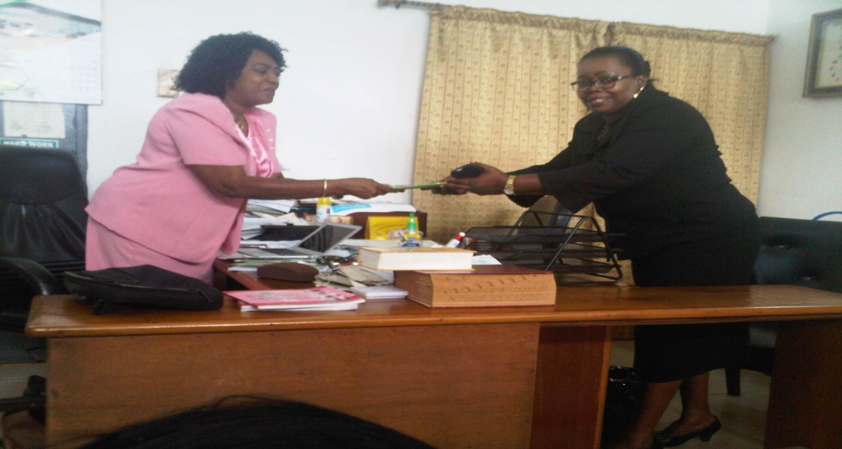
Picture showing Barrister Meg Nwagbo presenting the copies of the bill
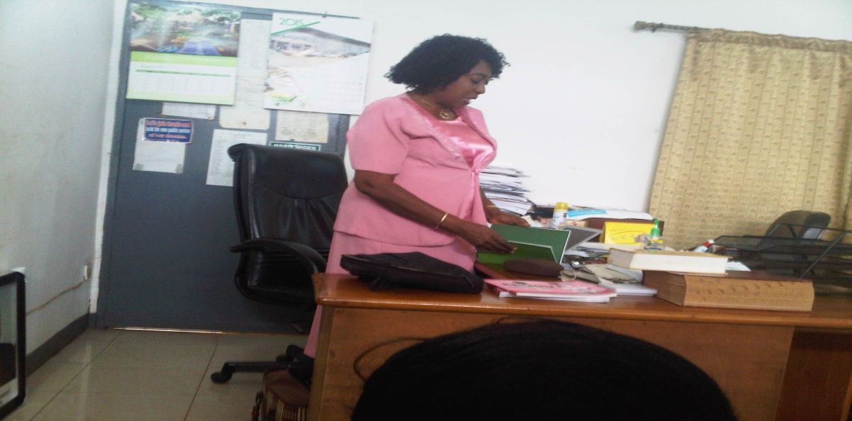
Picture showing the representative of the Hon Commissioner, Angela Gbanite Responding
Advocacy meeting with the Clerk of ENSHoA -5th October, 2015
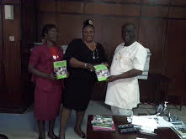
Picture showing the Speaker with NCAA State Coordinator and Program Officer

Advocacy meeting with Hon. Dr. Emeka Ogbuabor, House Committee Chairman on health (co- sponsor)-1st September, 2015
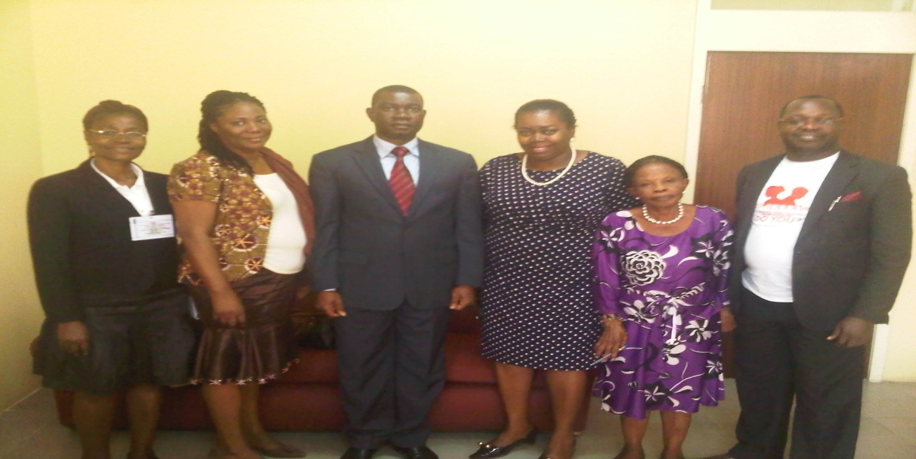
Picture showing Hon. Dr. Emeka Ogbuabor (middle) and NCAA team on advocacy visits in his Office
Advocacy meeting with the Parish Priest of St Mary’s Catholic Church Uhunowerri in Igboeze South LGA of Enugu State. 10th of September, 2015

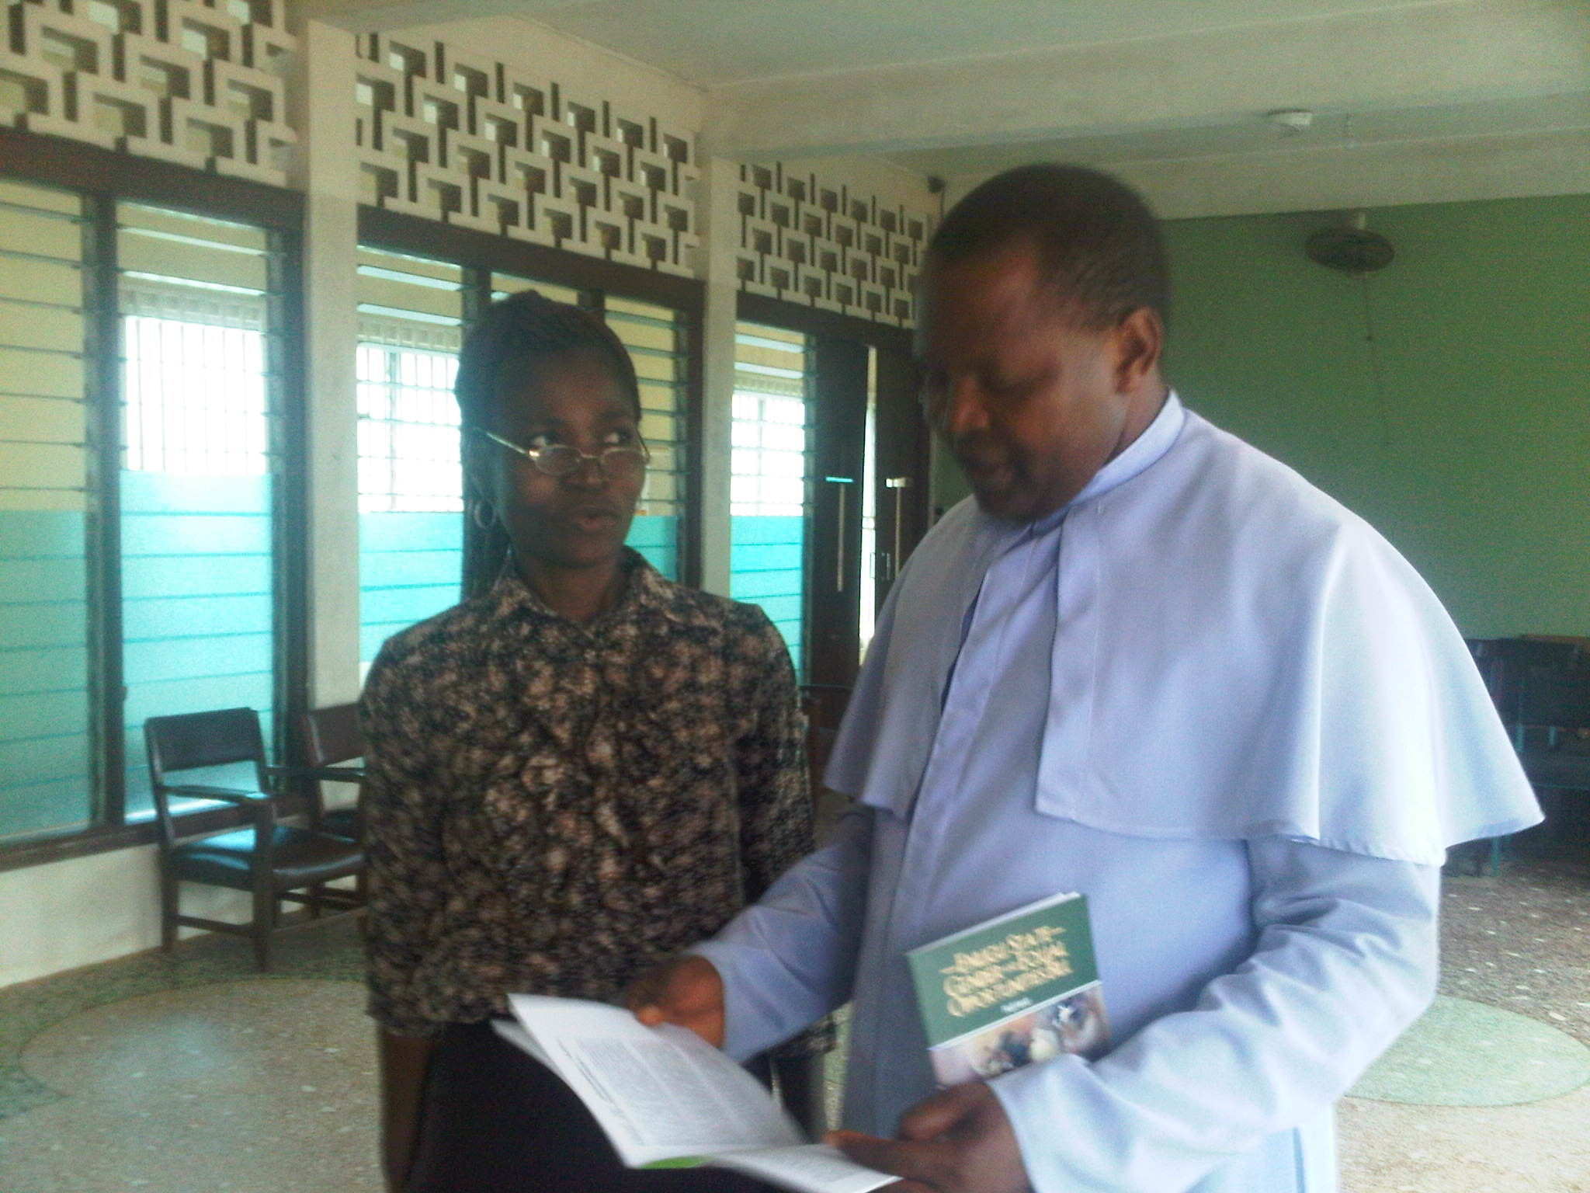
Picture showing the Program Officer and Rev. Fr Obe discussing on the sections
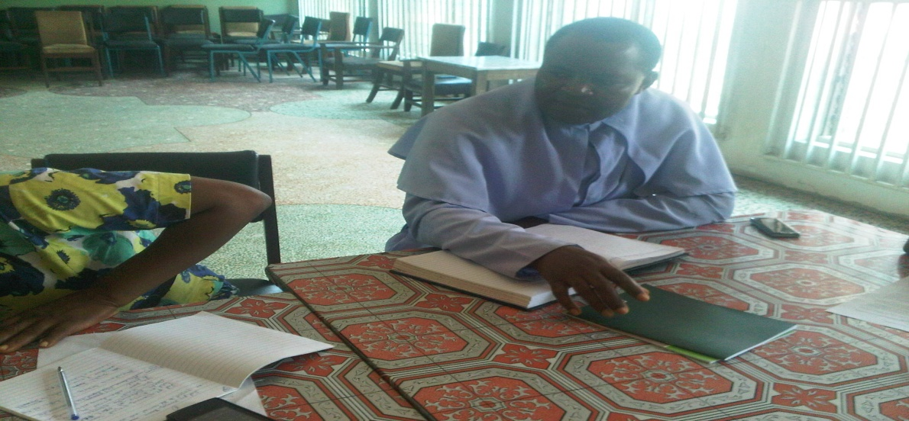
Picture showing the priest listening to my presentation of the bill at his parish hall
Advocacy meetings with the House Committee Chairman on Judiciary , Hon Barrister Philip Nnamani and House Committee Chairman on Gender, Hon. Lydia Nkechi Omeje on Tuesday , 15th of September,2015.
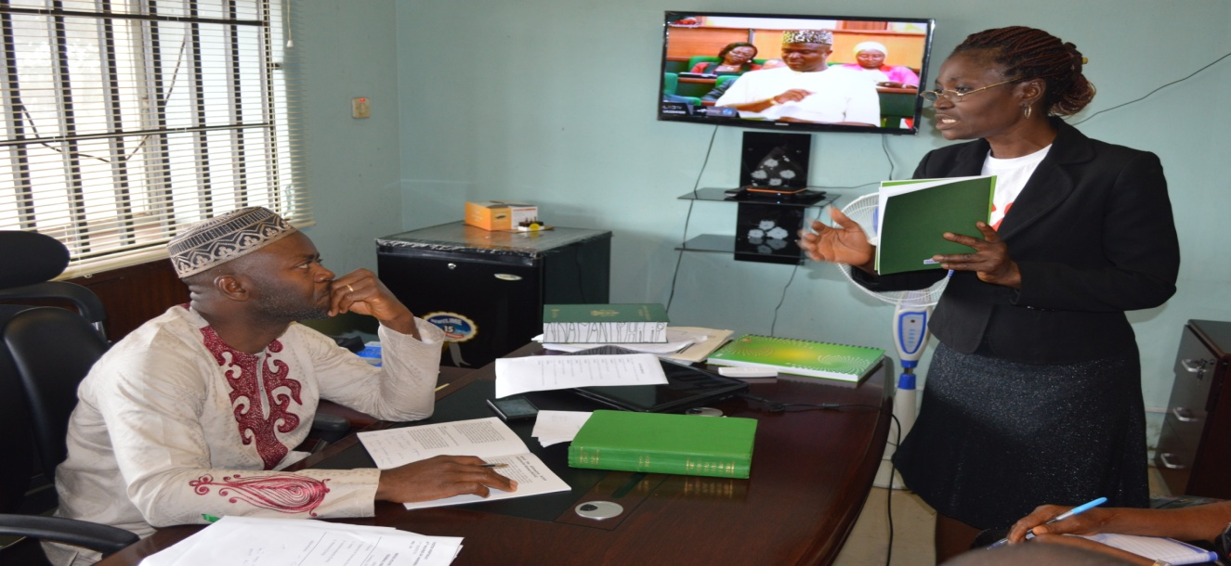
Picture showing NCAA Program Officer speaking to the House Committee on Judiciary – Hon Philip Nnamani Iloabuchi

Picture showing NCAA Member presenting GEOB officially to the Committee Chair on Judiciary in his office
Advocacy meeting with the Chairman House Committee on Gender, Hon Lydia Nkechi Omeje Ogbu
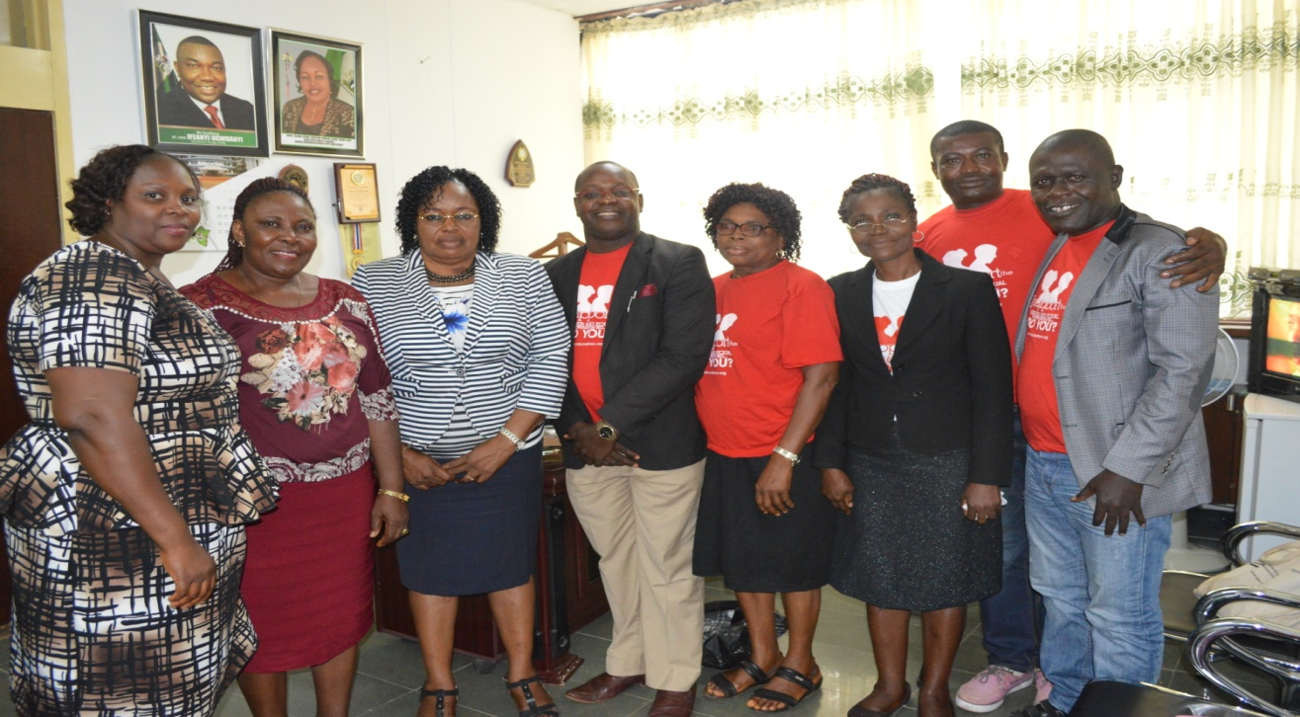
Group photograph of NCAA members with the House Committee Chairperson on Gender, Hon Lydia Nkechi Omeje Ogbu (3rd from left)
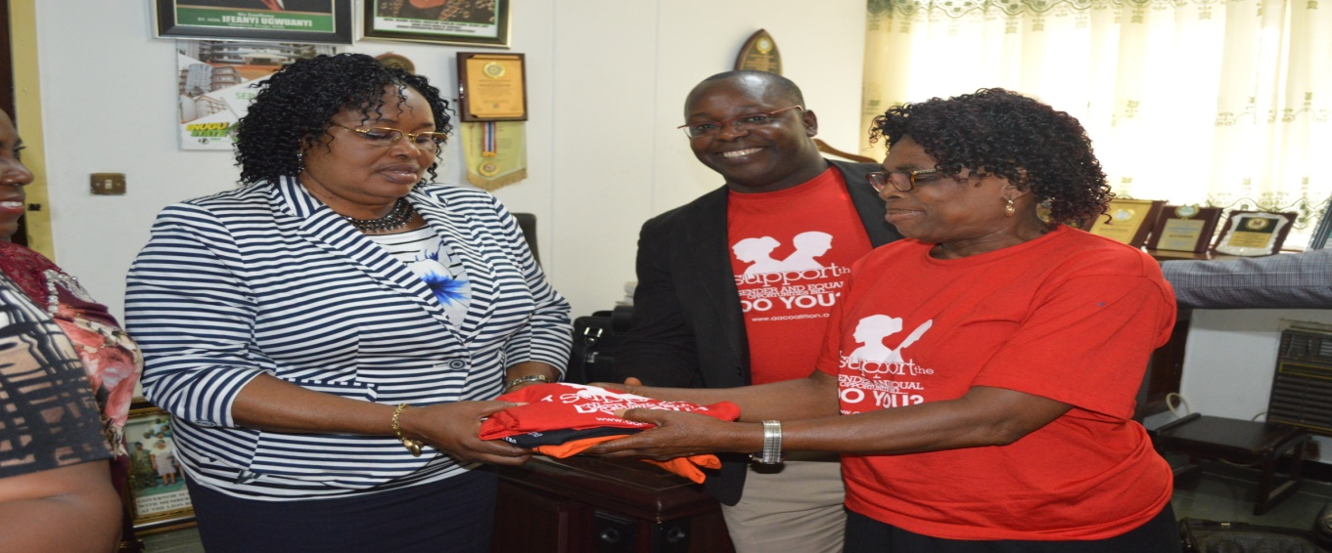
Picture showing Christy CIRDDOC handing over the T’ shirts to the Gender Chairperson (Sponsor of GEOB)

Advocacy visit/ meeting to the Traditional leader of Uhunowerri community in Igboeze South LGA

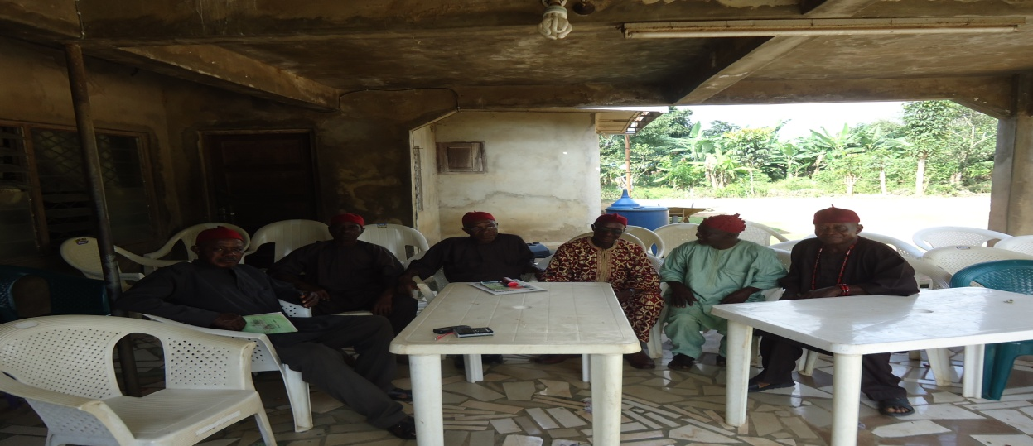
Picture showing some of the cabinet members of Uhunowerri –Igboeze South LGA

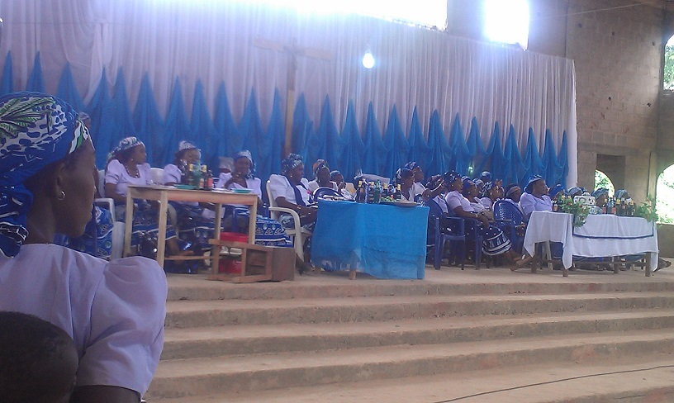
Executive’ members of the CWO, St Anthony Catholic Parish, Nguru in Nkpunano, Nsukka LGA
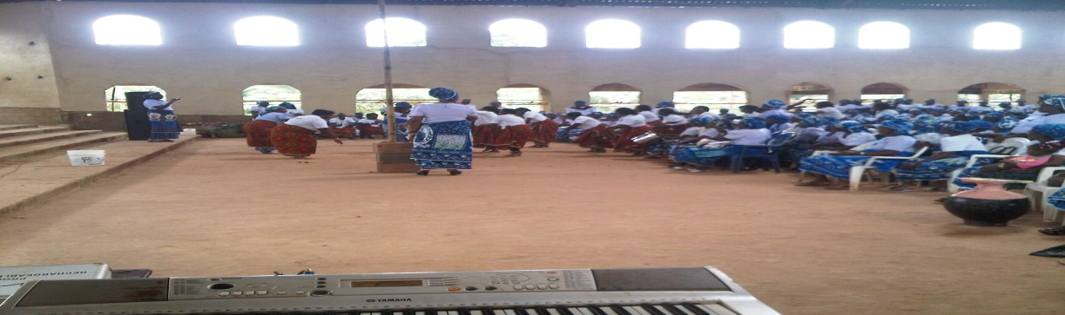
Picture showing the dancing group entertaining the women and guest
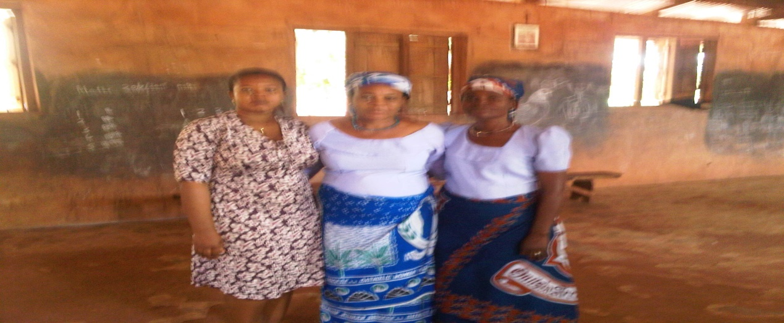
Picture showing the PG of CWO Nguru Dr. Mrs. Agu (middle), Virginia Obianyo NCAA PO (Right) and Ogechukwu Enwelum, NCAA (Left)
NCAA/Nollywood Script Development workshop held on 5th and 6th August 2015 at Dannic Hotel Orange Hall Enugu.
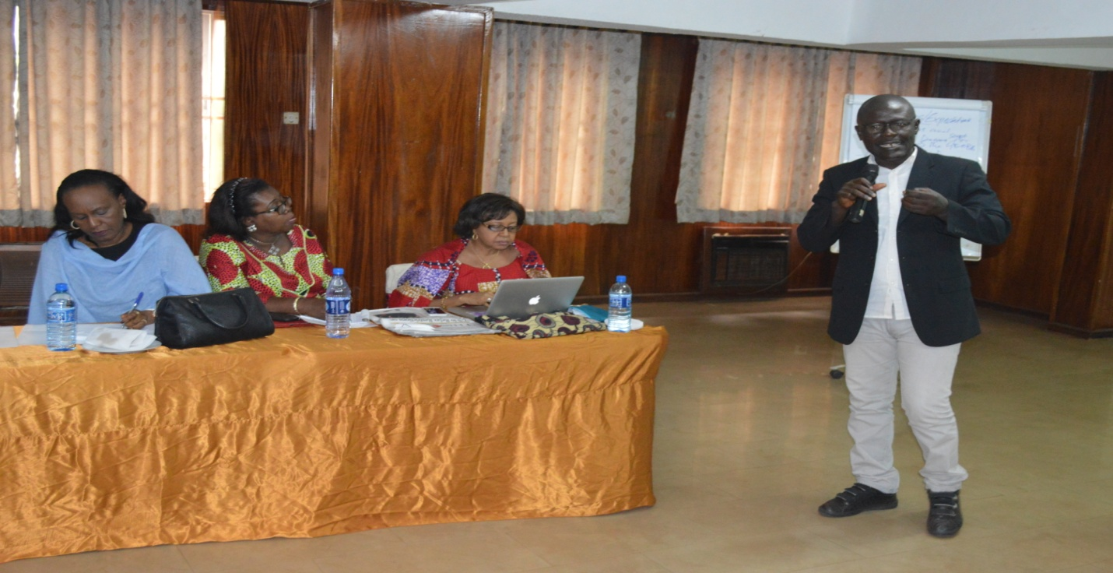
Newton Barabara presenting a paper on Movie for Development at Dannic Hotel, Enugu
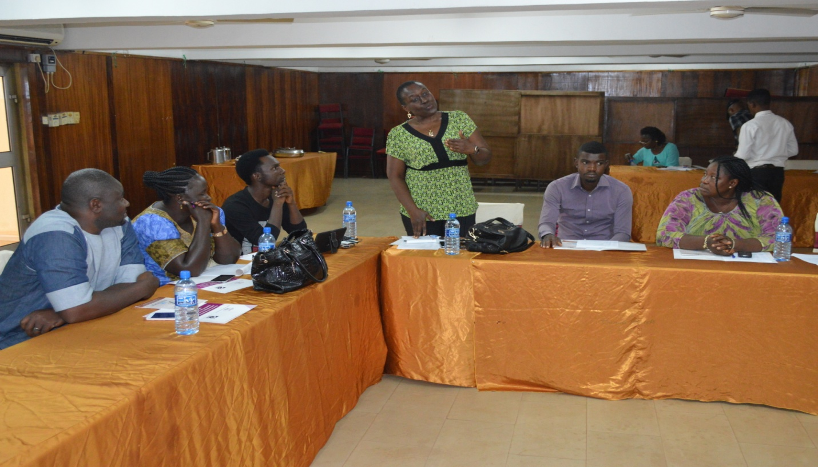
V4C Reps addressing the participants during the workshop

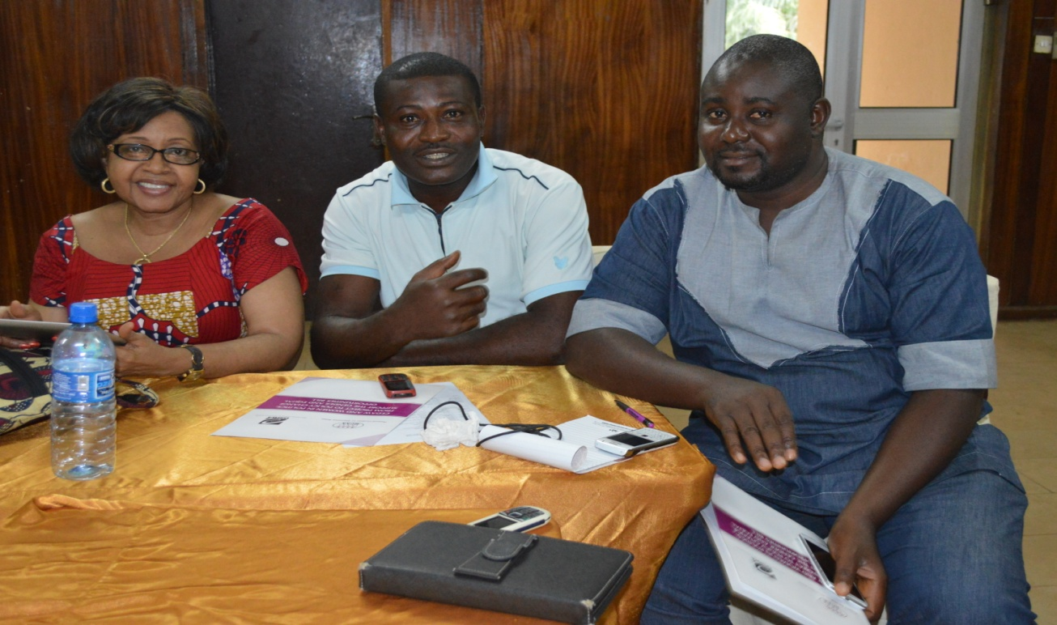
Picture showing the National Coordinator, James Eke and REP from GTU, Abuja
October, 2015 Narrative Report
- Advocacy to the clerk of the House – 5th October
- Stakeholders meeting – 14th October
- Sensitization workshop for committee secretaries , HODs and selected PAs of Principal Officers- 19th October
Advocacy meeting with the Clerk of ENSHoA -5th October, 2015
The meeting started at 12.45 pm at the office of the clerk, Mr Chris Chukwurah. Members of NCAA advocacy team comprising the State Coordinator, Barrister Nkiru Ugwu Nwabueze, Barrister Chinwike Okereke (PIC Chairman) and the Program Officer were highly welcomed by the Clerk. Self introduction was done. This was followed by a brief speech by the State Coordinator.
In her brief remark, she said that the purpose of our visit was to seek for your technical advice as an experienced clerk who had been on the business of legislation for a long time on how the bill will be presented to this Assembly without hedge.
She said that aside seeking for technical advice, we also solicit for your collaboration as one of the male champions that will support both legislative process and the passage of the bill. She mentioned some of the States that have passed the bill.
In addition NCAA state Coordinator, Barrister Nkiru Nwabueze reminded the clerk of the letter to his office for the release of the HODs, Committee Secretaries to attend a workshop on ESEOB at Dannic Hotel on 19th October, 2015.
After the brief, she officially presented two copies of the bill (graphic and full text) to the Hon. Clerk for him to go through it and effect changes where necessary. She also talked about forth coming Stakeholders meeting with the House members at Nike Resort Hotel Enugu, scheduled for 14th of October, 2015.
Responding to the request made by NCAA, he accepted to throw his weight on the bill with the condition that we will carry them along and said that he will read through the bill and communicate his findings to us on or during the meeting on the 14th October. He also assured us that he will do everything possible to see that the bill will be passed into law in this assembly in Enugu State.
Fourteen (14) T’ Shirts were given to him for his office staff.
Picture showing the Speaker with NCAA State Coordinator and Program Officer
STAKEHOLDERS’ DIALOGUE/CONSESNSUS BUILDING ON THE Enugu State EQUAL OPPORTUNITY BILL, HELD AT THE BOARDROOM, NIKE LAKE HOTEL, ON 14TH OCTOBER, 2015.
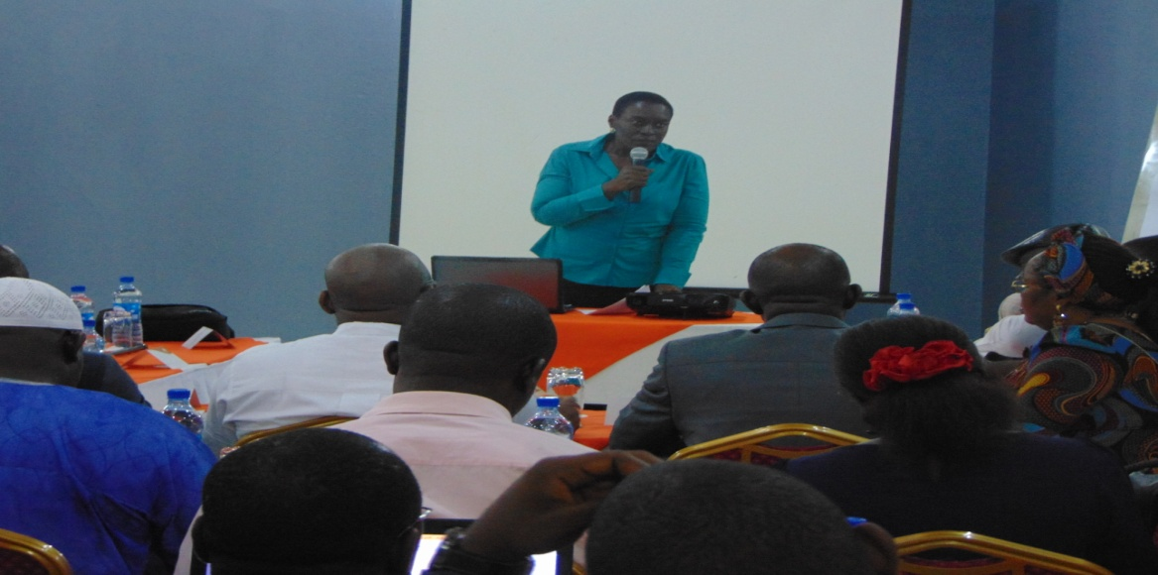
V4C State Coordinator for Enugu State, Kobi giving her goodwill message
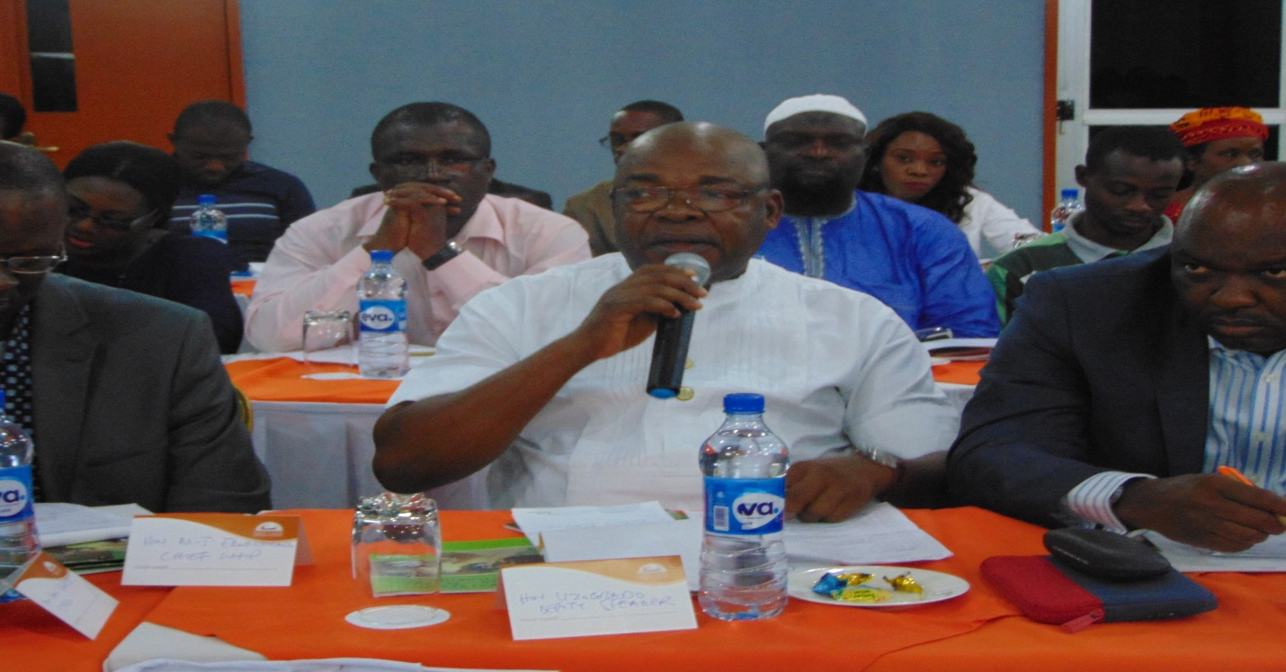
Picture Showing Rt. Hon Donatius Uzogbado making his speech in support of the bill.

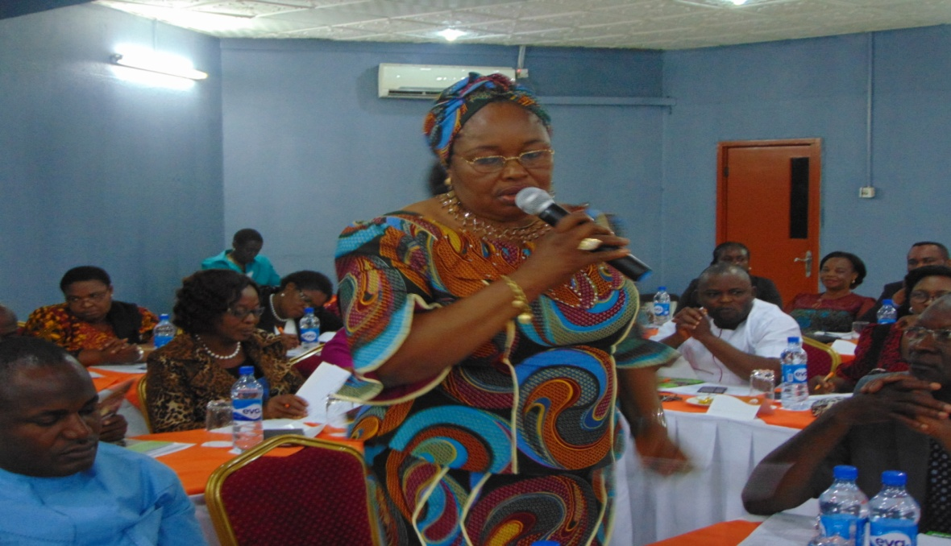

Picture showing the Committee Chairperson on Gender, Rt. Hon. Dame Lydia Nkechi Omeje –Ogbu- sponsor of the Bill giving her good will message.

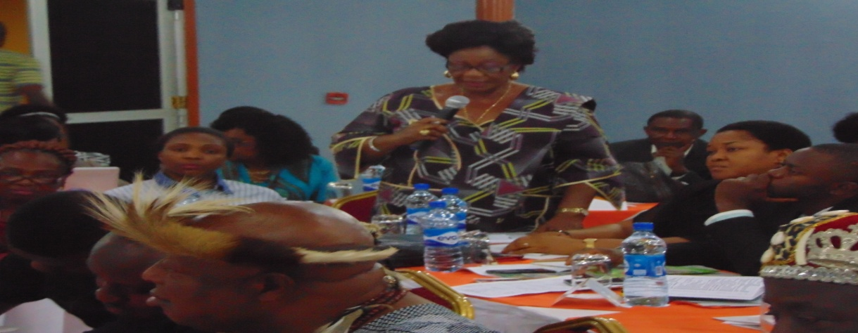
Princess Peace Nnaji, Hon Commissioner for Gender Affairs and Social Development making her opening comments on the proposed bill.
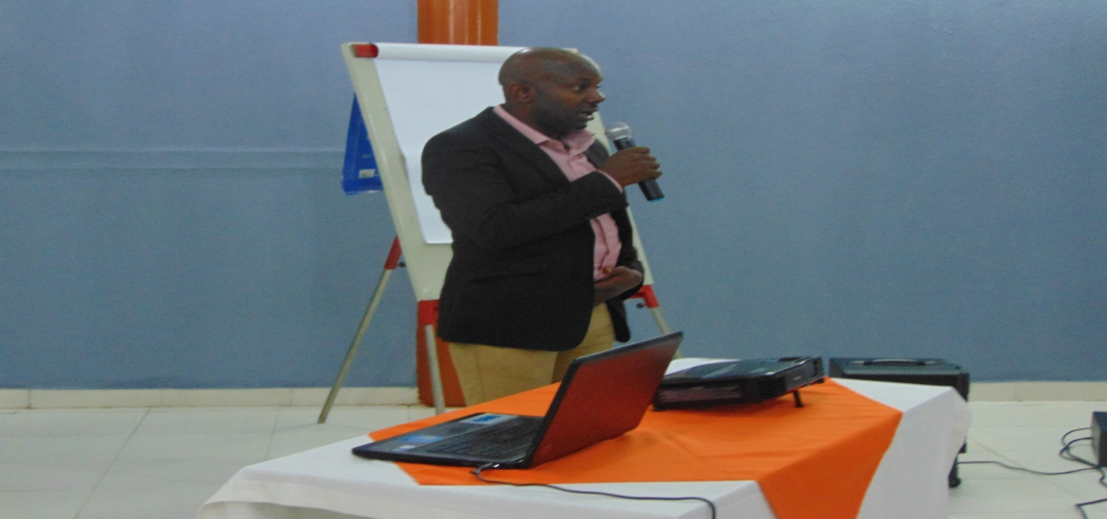
Barrister Ujoatumba Esq. making a comparative analysis of GEO Bill
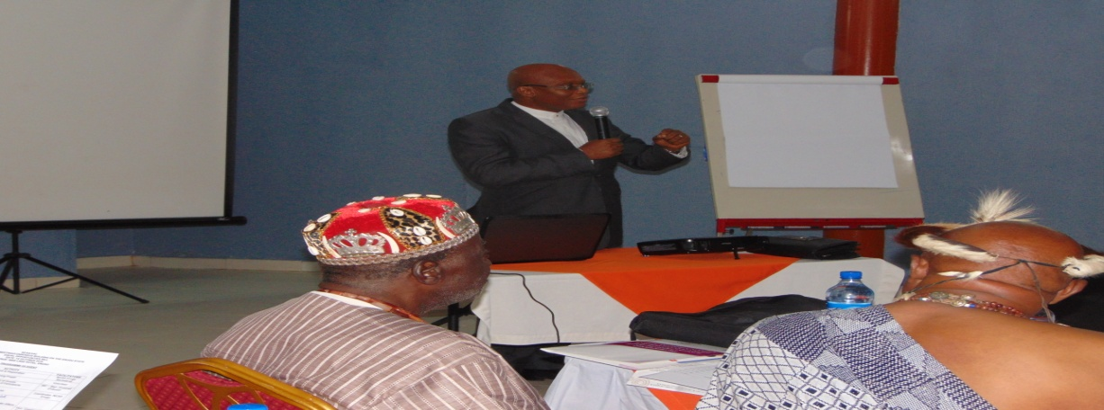
Barrister Akaraiwe making section by section analysis of the Bill
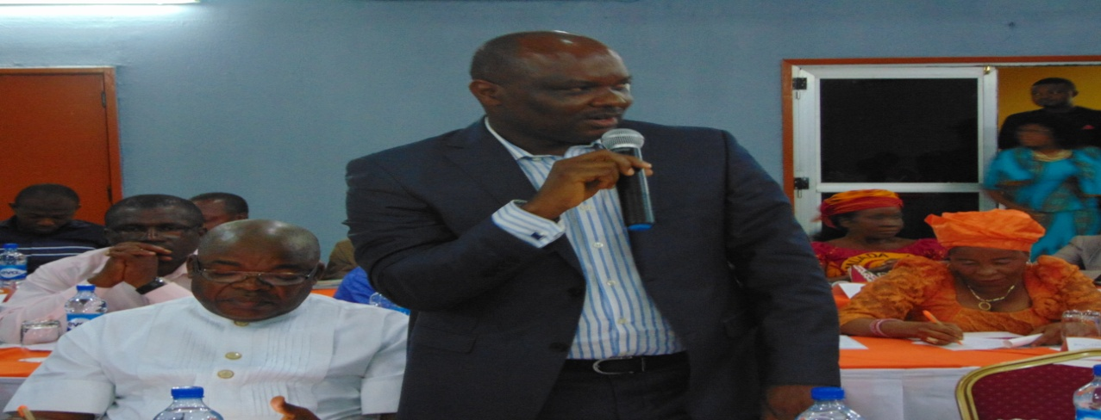
Picture showing the Leader of the House, Rt. Hon. Ik Mellitus Ezeugwu speaking on the Bill
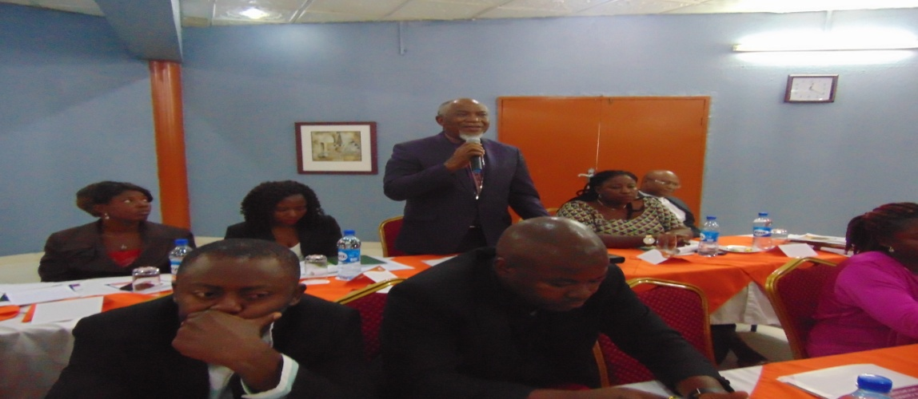
Rev. Obi Onubogu of the Pentecostal Fellowship of Nigeria (PFN) making his inputs
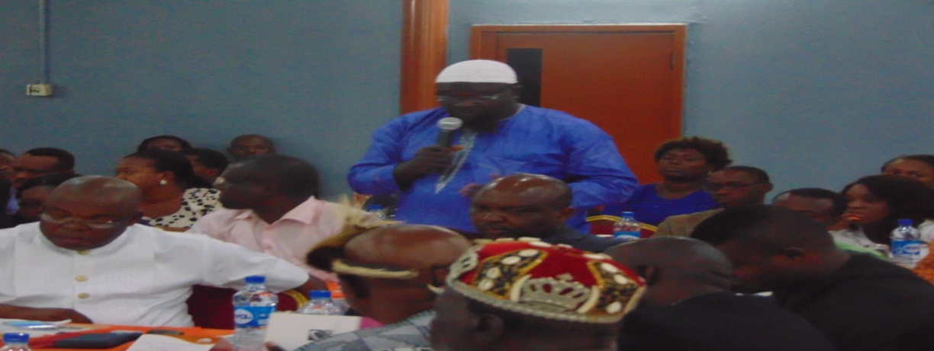
Alhaji Sadau representative of Imam of Enugu State making his own contribution on the Bill

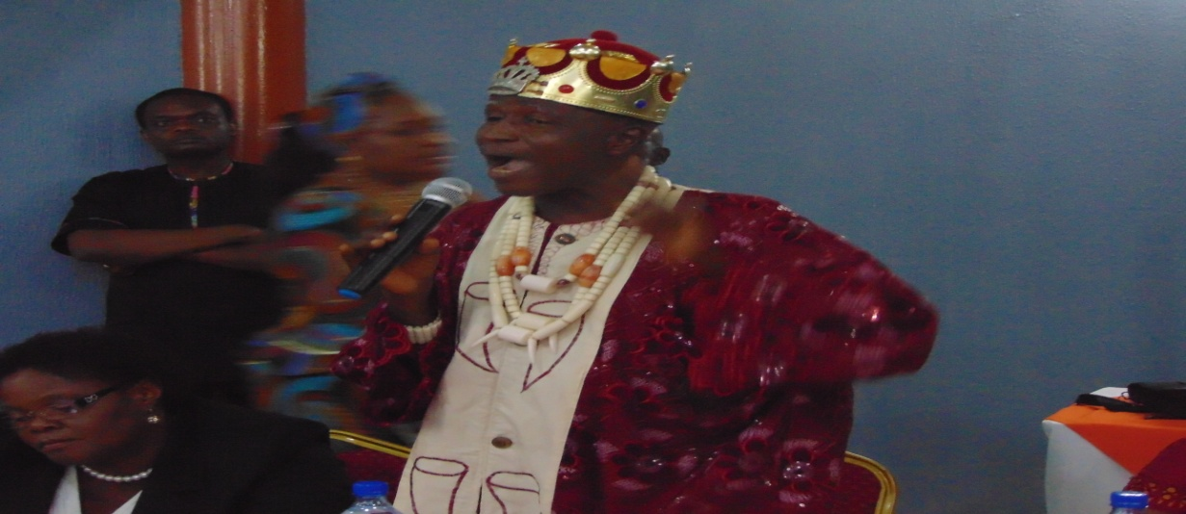
HRH, Igwe Barrister, R.S.N Eze speaking on the importance of passing the bill into Law

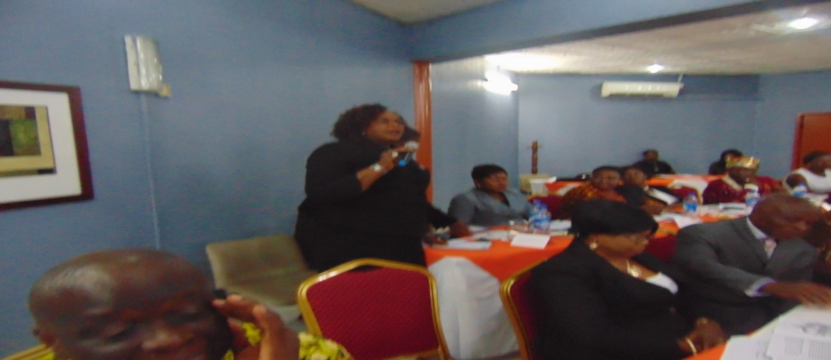
Barrister N.M. Ezeani representing Dr. Joy Ezeilo (WACOL) making her contributions on GEOB
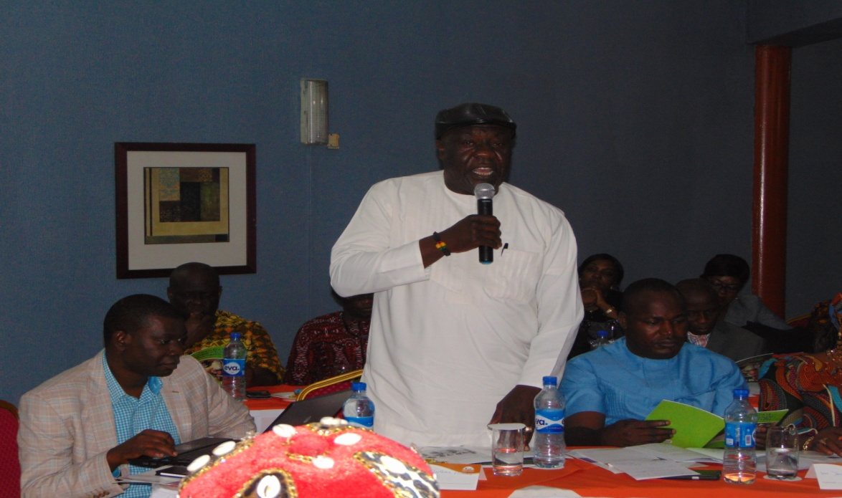
Rt. Hon Johnbul Nwagu making his inputs on ESEOB
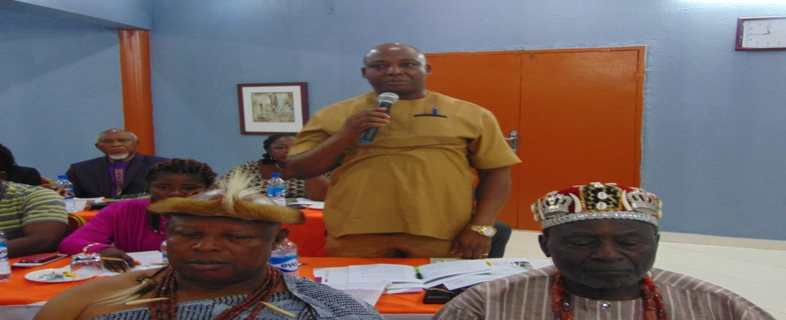
Hon Paul Nnajiofor, House Committee Chairman on Information making his Contributions on the Bill.
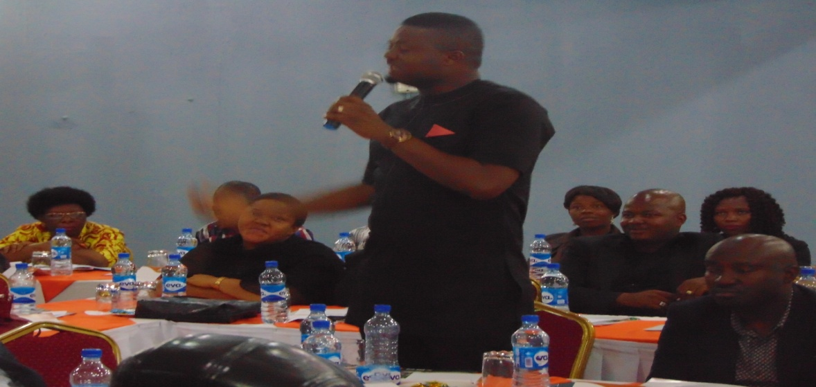
Hon Chima Obieze making his comment on the Bill

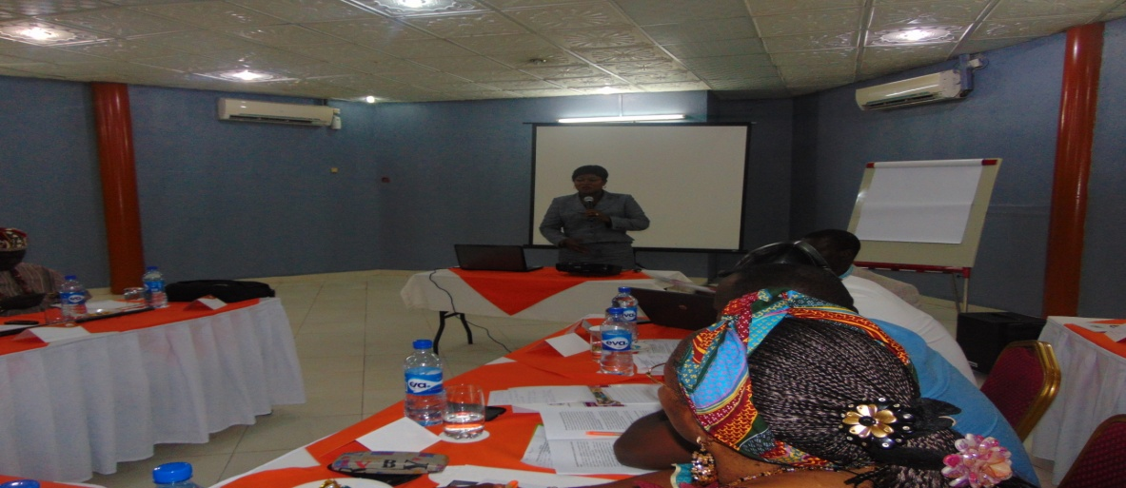
Dr Lizzy Orji responding to the issues raised by the House Members

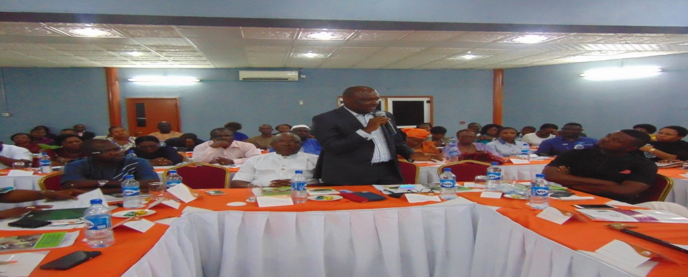
Cross- section of ENSHoA Members present at the meeting
- The Honorable Commissioner for Ministry Of Gender Affairs, Hon. Princess Peace Nnaji;
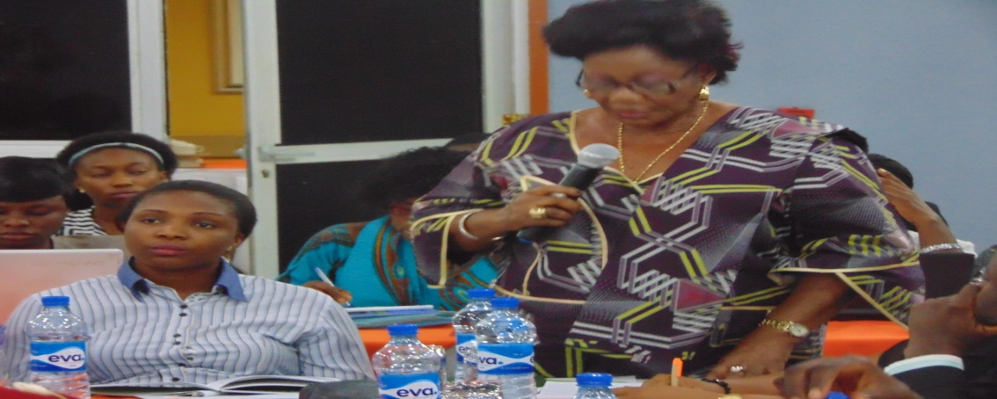
Hon Commissioner for Gender Affairs and Social Development giving her goodwill message
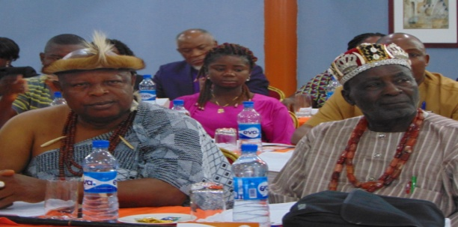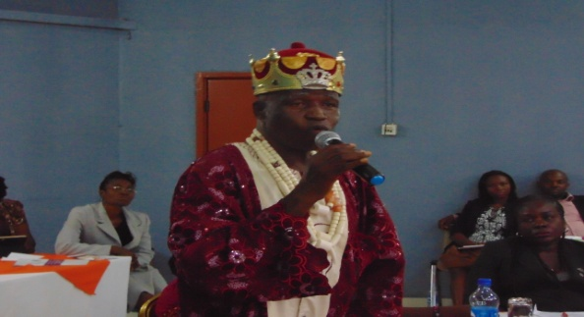
HRH Igwe P.I Okoro &HRM Igwe Chris Ogakwu HRH, Igwe Barrister R.S.N Ezeh

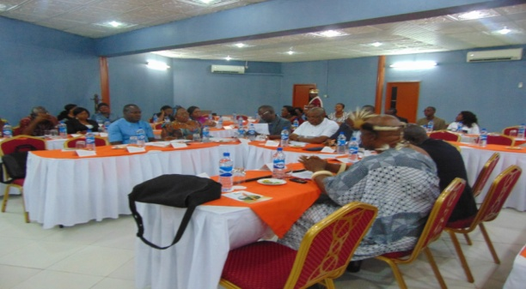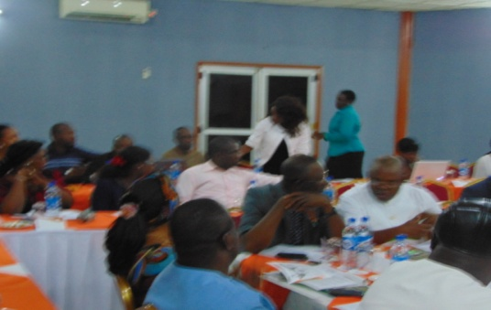
Cross Participants at the stakeholders meeting at Nike Resort Hotel on 14th October, 2015One day follow up stakeholders forum with Committee Secretaries, HODs and some selected PAs of principal officers of the House on Gender and Equal Opportunities Bill of Enugu State held on 19th October, 2015 at Dannic Hotels Enugu

Visits to Enugu State House of Assembly (ENSHoA)
As part of the activities in Objective 3 of the reviewed work plan of action- Ensure the formal presentation of the bill to the House of Assembly, the program officer made a total of 16 visits to the Enugu State House of Assembly legislators to meet with Sponsor of the bill Rt Hon. Dame Lydia Nkechi Omeje-Ogbu and the Hon Speaker, Rt Hon. Edward Ubosi to discuss the GEOB presentation in November, 2015. The outcome of these visits was that the formatted Enugu State Equal Opportunities Bill (ESEOB) will be printed and submitted to all the House Members for them to read through and ready to give their own view on the bill.
Also, NCAA was advised to publish the bill in the national dailies. The newspaper copies will be handed over to the speaker and the sponsor for quick presentation. The table above shows the dates of the visits.
Meeting with relevant House Committee Secretaries/HODs on legal matters
On the 6th of November, 2015, the Program Officer held a closed door meeting with the relevant House committee secretaries and HODs on legislative matters. The purpose of this crucial meeting was to collaborate with NCAA to lobby some of the relevant /principal officers of the house for the official presentation of the bill.
The outcome of the meeting was a suggestion to write to the speaker and the sponsor: requesting for the approval for formal presentation and publication of the ESEOB in November, 2015; NCAA should schedule to meet the speaker and the sponsor one on one to discuss the issues raised by the group – Happy home foundation; NCAA should organize a one day meeting with the oppositions to critically study the bill and make their inputs since they could not make it during the stakeholders meeting at Nike resort hotel; and one on one visits should be made to 4 Hon. Members who opposed the bill during the stakeholders meeting.
Eight committee secretaries(3 males and 5 females) namely Barrister Fabian Nwigbo, Barrister Dennis Dunu, Barrister Anigor Ngozi, Barrister Emeka Aroh, Mrs Perpetua Nwafor, Mrs Jovita Keleze, Mrs. Christiana Ekwe and Mrs. Mba Tochukwu attended the meeting.
One on One Visits to the 4 legislators in the opposition of the Bill
On the 23rd of November, 2015, the Program officer visited the 4 legislators that opposed the bill during the stakeholders meeting at Nike Resort Hotel, Enugu.
The purpose of the visit to bring them on board to understand the content of the bill and to enlighten them on the effects of having the bill passed into law. We shared the reports of our survey on women exclusion and other harmful traditional practices that endanger their lives.

One of such issues discussed was the Igboeze North girls and Women enslavement; denial of inheritance rights, domestic violence, sexual abuse in rural communities.
At the end of each visits, they agreed to support the passage if some of the ambiguous contents were esponged and the bill made specific. They also raised issues on section 6 affirmative action and section 4 on discrimination. They stated that women are fully supported by parties in every political position unlike their men folk. They suggested that passing such bill into law cannot increase women participation in politics and public life but we should devout more time in training women and young girls in schools on self esteem and in strategic thinking.
Meeting with the Sponsor and the Speaker on approval to publish the bill and presentation of the bill in the ENSHoA
On the 26th of November, 2015, a meeting was held in the office of the Speaker on official presentation of the bill and approval to publish in the two national dailies. Earlier on the 16th of November, a letter demanding for the bill to be presented on the 26th November, 2015 was submitted in his office.
The outcome of the meeting were that approval for the publication was granted; advised that the formatted bill be printed and circulated to all the House members; and a copy made available to the Clerk for scheduling into order paper of the house.
Hon. Dame Lydia Nkechi Omeje Ogbu (sponsor), Mrs. Perpetua Nwafor (committee Secretary On Gender Affairs) Mrs. Virginia Obianyo (NCAA Program Officer), Hon. Philip Nnamani (Judiciary), Barrister Fabian Nwigbo (Committee Secretary on Judiciary) and Barrister Dennis Dunu (HOD Legislative Matters) attended the meeting
Advocacy/Lobby Visit to the House committee on Judiciary (Hon. Philip Nnamani
Following the outcome of the meeting with the speaker to give the Judiciary committee Chair the formatted bill for further inputs, a visit was made to Hon Phi;ip Nnamani on the 27th of November, 2015.
The essence of the meeting was to remind him of the promise he made to us during the advocacy visit in his office in September that he will ensure the bill is passed into law in Enugu State and to facilitate his recommendation to the speaker.
After the one- on- one talk, he re-assured us that the bill will sale but that the only problem is for us to work hard to sensitize all the relevant stakeholders to support the bill during the Public hearing on the bill. He said that he still remembered his promise and that he would keep to it.
Mrs. Virginia Obianyo and Christie Nwankwo of CIRDDOC attended the meeting.

One day workshop with the opposition group
Happy Home Foundation is a Catholic Organization that is championing the use of natural family planning (Billings) method as the only way of controlling birth. This group of people has vehemently refused to understand the content of the bill; they said that this bill is very much in support of gay / same sex marriage which is against the natural laws of pro-creation. They have consistently fought against the passage of this bill into law despite all efforts made by NCAA to clear their doubts and misconception.
They were among the groups that were invited to the stakeholders meeting at Nike Resort on the 14th of October, 2015; and they did not attend rather they sent their program officer who came to the venue 30minutes before the end of the meeting.
On the 21st of October, 2015 according to the Sponsor of the bill, the happy foundation made a demonstration saying that they do not want the bill to be passed into law in Enugu State. In response to their request, the speaker told them to go home and read through the bill to bring out issues in the bill that needed to be amended or put up issues they want to see in the law.
Some of the issues they came up with were already amended during the stakeholders meeting on the 14th and on the 19th of October, 2015 at the Committee Secretaries meeting. The amended sections were as followed:
- Section 1- title, citation and commencement
- Title -A bill for a Law to Provide for the Enugu State Equal Opportunities for Men and Women and Other Matters Related Thereto.
- Citation – This bill shall be cited as Enugu State Equal Opportunities Bill and not Gender and Equal Opportunities bill
- Section 2- Interpretation
- “Court” means any governmental institution with the authority to adjudicate legal disputes between parties in Nigeria.
- “Equal Opportunities” – Fair play and a level playing ground for all.
- Section 4(a) - Representative of such organ or agency mentioned above.
- Section 7 (v) - A widow shall have the right to remarry, and in that event, to marry the person of her choice and the custody of children to be determined by the former spouse family and the new spouse.
- Section 7 (vii) - women and men shall have the right to inherit, in equitable shares, their parents acquired properties.
- Section 12 (a) - all children under the age of 5 and not 12
- Section12(C) - without prejudice to subsection a & b the free medical services contemplated are not to include abortion and abortion services.
- Section 15- every woman shall have equal rights with men to confer their national citizenship on their children.
- Section 17 (b) - Equal rights to freely choose a spouse of opposite sex.
Based on this premise, a one day meeting to review the ESEOB was held with the opposition groups to discuss clause by clause the bill on the 25th November, 2015 at CIRDDOC office. The meeting ended at 3.40 pm with closing prayer said by one of the participants from Pentecostal Fellowship of Nigeria (PFN)
The outcome was that the bill has been reviewed by those present and a clean draft copy of the reviewed bill with a letter requesting to support for the presentation forwarded to the absentee Organization.
December 2015- Visits to the House for the publication of the bill in the national dallies
From 1st – 10th Dec., a total of 11 visits has been made. Among them was the visit to the ENSHoA PRO, Mr. Ugwuanyi as was directed by HOD on legislative matters, Mr. Dennis Dunu and Barrister Fabian Nwigbo, committee Secretary on judiciary for the publication of ESEOB in the Enugu State Printing and Publishing Company.
The bill will be published on the 16th of Dec. 2015 in Daily Star Newspaper and as promised by the Speaker, the bill will be officially presented in the floor of the House by their first sitting in January, 2016.
Success stories
More than two third (2/3) of the House members were in support of the bill and they vowed to throw their weights on the bill to ensure its passage and assents. One of such people is Rt Hon. Dame Lydia Nkechi Omeje- Ogbu who told me that after hearing the comments from the traditional leaders from Nsukka Zone during the Stakeholders meeting at Nike Lake Hotel, she was highly motivated to carry on with the cause. Again, during the 16th day’s activism, she publicly said that the only bill targeting women is now at the floor of the House and will be passed before the end of April, 2016. She made this declaration when addressing the participants at ENSHoA on the 26th of November, 2015.
Another significant success stories was that God has defeated the opposition group when they demonstrated asking the speaker to throw away the bill because it is very much in support of same sex marriage, equality with men and abortion. The speaker advised them that they should go through the bill and document whatever that is wanting in the bill and communicate back to him. This is because Enugu State needs such bill into law.
Challenges
- Inadequate commitment by NCAA Members.
- Lateness to NCAA activities by NCAA members especially during advocacy visits to house members.
- Excessive workload on Program officer
- Inadequate stipend for this job; and no motivation especially payment of 13th month
Report by Virginia Obianyo

